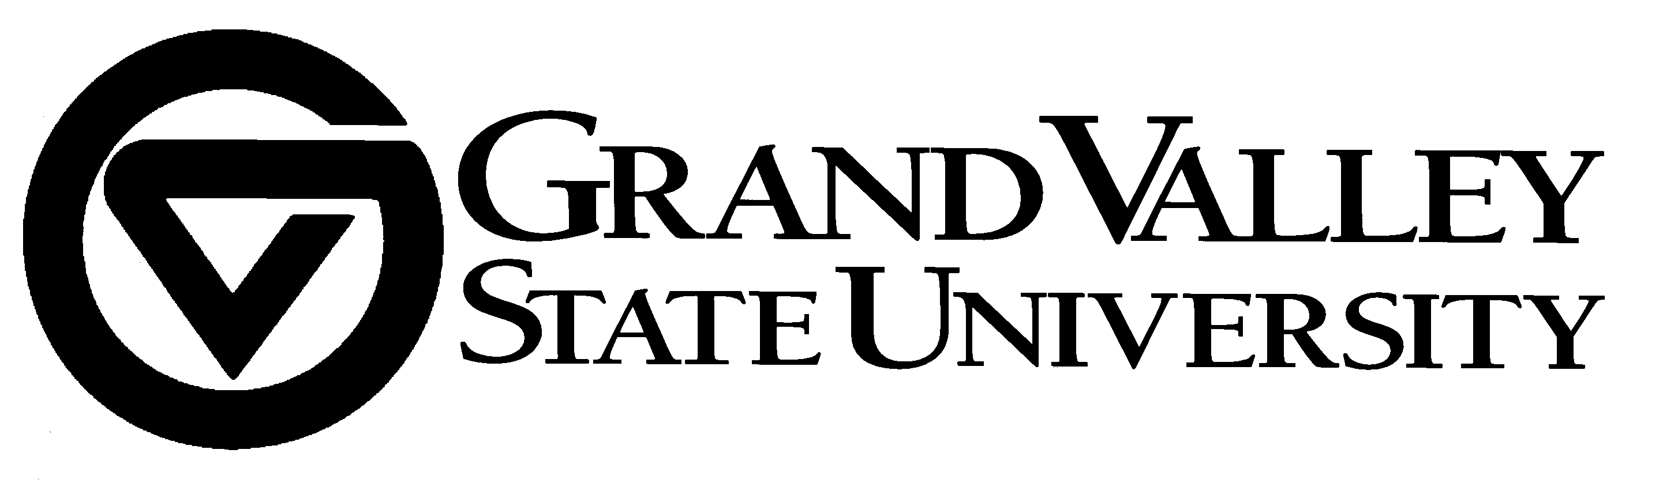
July 31, 2018

Grand Valley State University (GVSU) has evaluated all submissions received from our request for proposal for an elevator maintenance program … Reference bid #218-64. We have selected Schindler Elevator Corporation to provide the services. We look forward to their expertise in elevator technology and service for our elevators.

GVSU would like to thank all vendors and their companies for your time and participation in our request for proposal for these services. We look forward to your participation in future bid opportunities.

Best Regards,

Valerie Rhodes-Sorrelle, C.P.M.
Senior Strategic Sourcing Specialist

Procurement Services - 2033 Zumberge Hall - Allendale, MI 49401
Phone - 616/331-2283 - Fax 616/331-3287

